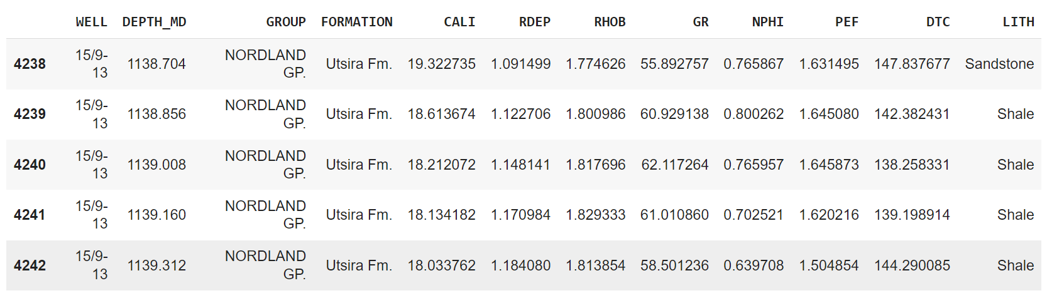

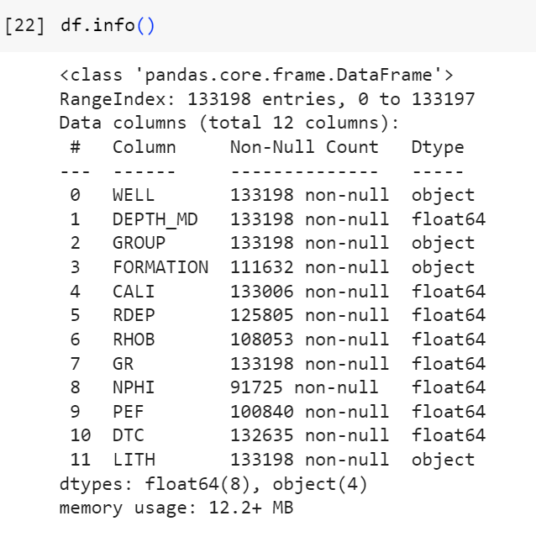

The parameters mentioned below are commonly measured in the field of well logging, which is a crucial technique in the oil and gas industry for understanding subsurface formations and making informed decisions during drilling and reservoir evaluation. These measurements play a significant role in lithology classification and can help identify the types of rocks and their properties. Here's an explanation of each parameter and its role in lithology classification:

Depth Curve ( **DEPTH_MD**) : The depth curve, also known as the depth log, represents the depth below the surface of the Earth at which various measurements are taken. It's a fundamental component in well logging and is used as a reference for other measurements.

Caliper Curve (**CALI**): The caliper curve measures the diameter of the wellbore. It helps identify variations in borehole size, which can affect other measurements and may indicate the presence of fractures or voids in the formation.

Deep Resistivity (**RDEP**): Deep resistivity is a measurement of the electrical resistivity of the surrounding rock. It provides information about the formation's composition and can help distinguish between conductive (e.g., shale) and resistive (e.g., sandstone) formations. It's calculated from electrical measurements made by tools like induction or laterolog devices.

Bulk Density (**RHOB**) : Bulk density measures the density of the formation material. It's often used to estimate porosity, which is crucial for determining the volume of hydrocarbons a reservoir might contain. High bulk density typically indicates denser, more lithified rocks like carbonates, while low bulk density suggests less dense materials like sandstone.

Gamma Ray (**GR**) : Gamma ray logging measures the natural gamma radiation emitted by the formation. It's useful for lithology classification because different rock types emit different levels of gamma radiation. For example, shale typically has a higher gamma ray signature than sandstone.

Neutron Porosity (**NPHI**) : Neutron porosity is a measurement of the hydrogen content in the formation. It helps estimate porosity by determining the amount of hydrogen, which is abundant in pore fluids (e.g., water and hydrocarbons). This measurement can differentiate between porous and non-porous rocks.

Photoelectric Factor (**PEF**) : The photoelectric factor (Pe) is a measure of the formation's ability to absorb and scatter X-rays. It provides information about the composition and density of the formation. The Pe can help differentiate between rocks with different mineral compositions.

Transit-Time of Compressional Wave (**DTC**) : This measurement, typically obtained from sonic or acoustic logs, determines the time it takes for a compressional sound wave to travel through the formation. It is used to estimate the rock's mechanical properties and can assist in distinguishing between various lithologies based on their sonic properties.

These parameters are calculated and displayed in well logs, which are records of measurements made as a function of depth. Geologists and petrophysicists analyze these logs to identify lithologies and make geological interpretations. Different lithologies will exhibit unique responses in these measurements, allowing experts to classify and characterize the subsurface rock formations and their properties.

The precise calculation methods and tools used for these parameters can vary, and often they involve complex mathematical algorithms based on the principles of physics and geophysics. The data from these measurements, along with other geological and geophysical information, are integrated to build a comprehensive understanding of the subsurface lithology, aiding in reservoir characterization and hydrocarbon exploration.

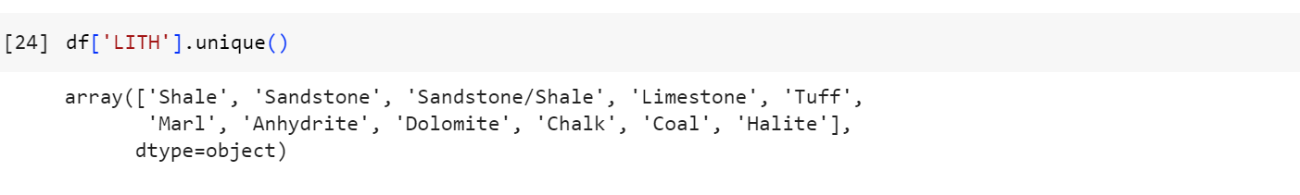

The list below includes various sedimentary rock types and rock classifications. Here's a brief explanation of each:

**Shale**: Shale is a fine-grained sedimentary rock composed primarily of clay minerals. It often has a platy or layered appearance and is known for its low porosity and low permeability. Shale is a common source rock for hydrocarbons and is often associated with natural gas and oil deposits.

**Sandstone**: Sandstone is a sedimentary rock composed of sand-sized grains, primarily quartz, feldspar, and other minerals. It has good porosity and permeability, making it an excellent reservoir rock for oil and natural gas.

**Sandstone/Shale**: This classification typically refers to a rock that contains both sandstone and shale layers. It may have alternating layers of these two rock types.

**Limestone**: Limestone is a sedimentary rock primarily composed of calcium carbonate (calcite). It often forms in marine environments and may contain fossils. Limestone is used in construction and as a raw material for cement.

**Tuff**: Tuff is a volcanic rock formed from the consolidation of volcanic ash. It can be fine-grained or coarse-grained and is often associated with volcanic eruptions.

**Marl**: Marl is a type of sedimentary rock that is a mix of clay and calcium carbonate. It often has a marbled appearance and forms in a variety of environments, including lakes and marine settings.

**Anhydrite**: Anhydrite is a mineral that can form sedimentary rock. It is an anhydrous form of calcium sulfate and is often found in association with evaporite deposits in arid regions.

**Dolomite**: Dolomite is a sedimentary rock composed of calcium magnesium carbonate (CaMg(CO3)2). It is similar to limestone but contains magnesium as well as calcium. Dolomite can form through the alteration of limestone.

**Chalk**: Chalk is a fine-grained, soft, and porous sedimentary rock made primarily of microcrystalline calcite. It is often associated with marine environments and may contain fossilized microorganisms.

**Coal**: Coal is a sedimentary rock made from the remains of plants that lived and died millions of years ago. It is a carbon-rich rock and is a valuable source of energy when burned.

**Halite**: Halite is the mineral form of sodium chloride (NaCl), commonly known as rock salt. It forms in evaporite deposits and is often associated with geological salt beds.

These rock types represent a range of geological environments and processes, and they have various industrial and economic uses. Geologists and petrophysicists use well logging data and other geological information to identify and classify these rocks when exploring subsurface formations for various purposes, including hydrocarbon exploration and mining.

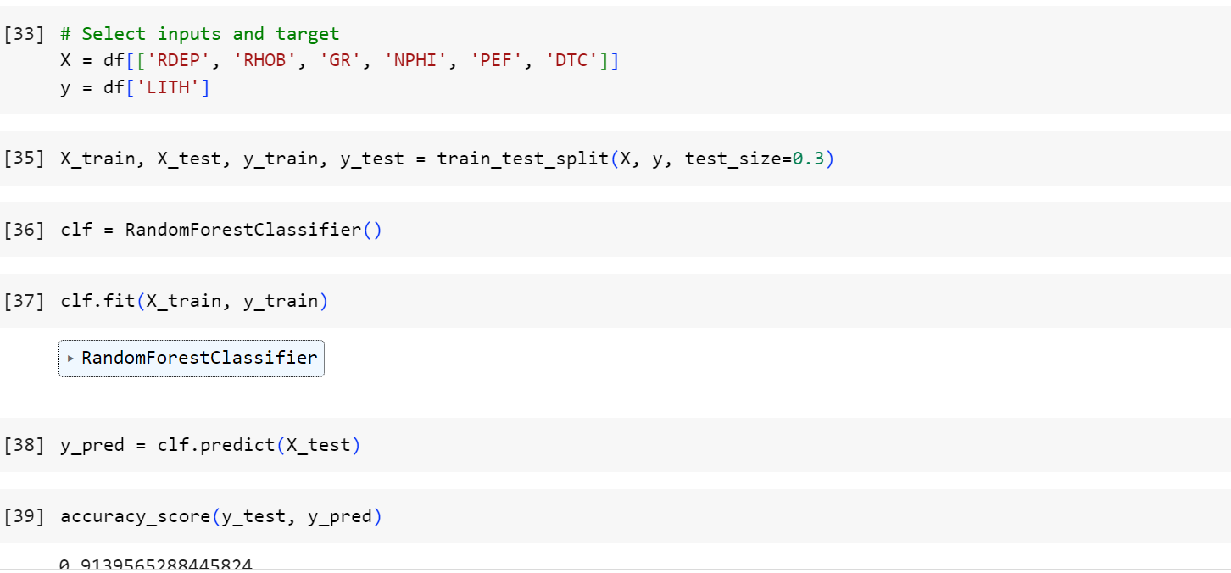

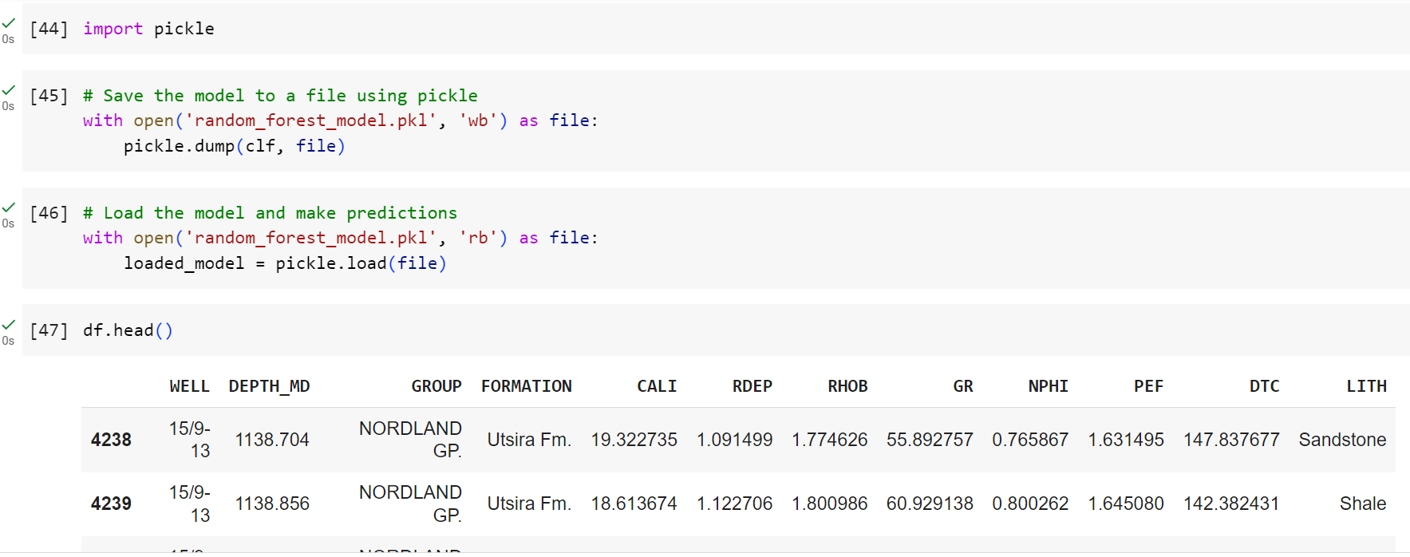

Save the trained random forest using the pickle library and then load it whenever we are required to make a prediction.